|  |  |  |  |
| --- | --- | --- | --- |
| **Qualification details** | | | |
| **Qualification National**  **Code & Title** | **ICT30120 - Certificate III in Information Technology (Release 1)** | **State code** | BFF7 |

|  |  |  |  |
| --- | --- | --- | --- |
| **Assessment Title**  *(as per DAP)* | **EXERCISE Code of Ethics - Considerations and Compliance** | | |
| **Unit National Code**  **& Title** | **ICTICT451 Comply with IP, ethics and privacy policies in ICT environments** | | |
| **Date Due** |  | **Date Received** |  |
| **Student Name & ID** | Richard Pountney 30007736 | | |
| **Student Declaration** | I declare that the evidence submitted is my own work:  ………………………………………………………….. | | |

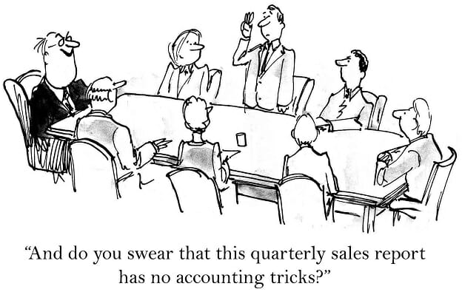

**EXERCISE 1:** What and where are the TAFE IP, ethics and privacy policies and procedures?

You can find it in the Student Code of Conduct

**EXERCISE 2:** What is your own role in protecting and fulfilling the requirements of the TAFE IP, ethics and privacy policy and procedures (Student code of conduct), to avoid infringement of IP and privacy requirements?

**EXERCISE 3:** What Support is given to ensure ethical compliance at TAFE?